June 25, 2026
Dear Senator/Representative:
The Leadership Conference of Women Religious (LCWR) represents nearly 300 congregations of Catholic sisters across the United States. Since 1727, we have educated generations of children, cared for the sick, fed and housed those most vulnerable, advocated for human dignity, and upheld the rights to vote, to work, and to access the fundamental freedoms and protections that sustain a just society.
As our nation approaches the 250th anniversary of the Declaration of Independence, communities across the country are preparing to celebrate this historic milestone. While stages are being built and public resources devoted to commemorations at the local and national levels, we are also compelled to reflect on another reality within the nation you represent and that we serve.
For nearly three centuries, we have stood alongside those who have experienced unequal access to the resources necessary for human flourishing, barriers to full participation in civic life, limitations on the exercise of free speech, and inequities within our systems of justice. Many of you have known Catholic sisters personally, been educated by our institutions, or partnered with us in advancing the values of faith, freedom, dignity, and truth.
In preparation for this anniversary, we have gathered in prayer, dialogue, and discernment to consider how best to exercise our moral responsibility on behalf of those most in need at this critical moment in our nation’s history.
This process resulted in the LCWR Declaration of Commitment. Within the declaration, we have articulated the convictions which guide our response to the challenges of these times, inviting our witness in prayer, moral courage and action in service of the common good. We invite you to join us in this way of creating the hope for a future beyond the 250 years of history we honor.
We respectfully ask that you take the time to read the LCWR Declaration of Commitment and consider the witness of the leadership of Catholic sisters whose signatures affirm their solidarity with all who believe in a government truly dedicated to serving its people. We welcome the opportunity to be in dialogue with you as we seek to build bridges of relationship.
In a spirit of fidelity to the values that helped shape this nation and continue to guide our mission, let us pray for peace in our world; for justice, mercy, and compassion; and for the renewal of our nation’s commitment to ensuring that life, liberty, faith, and the flourishing of the human spirit are possible for all.
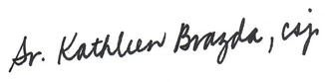
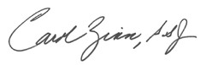
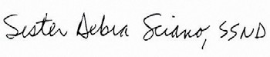
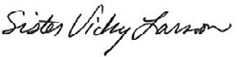
Respectfully submitted in the values we share,

Kathy Brazda, CSJ,
LCWR Past-President
Carol Zinn, SSJ,
LCWR Executive Director
Deb Sciano, SSND,
LCWR President-Elect

Vicky Larson, PBVM, LCWR President
Cc: Archbishop Paul Coakley, President, United States Conference of Catholic Bishops and Anthony Granada, Associate General Secretary for Policy
8737 Colesville Road, #610 | Silver Spring, MD 20910

